- ASSEMBLE AND DISASSEMBLE A PC

Q1. List all the main components you find inside a desktop PC after opening the cabinet, and write a short description (1-2 lines) for each.
Ans.

Component | Description (1–2 lines)
Motherboard | The main circuit board that connects and allows all hardware components to communicate with each other.
CPU (Processor) | The brain of the computer that performs calculations and executes instructions from programs.
CPU Cooler (Heatsink & Fan) | Cools the CPU by removing heat to prevent overheating and maintain performance.
RAM (Memory) | Temporary memory that stores data and programs currently being used by the CPU.
Graphics Card (GPU) | Processes graphics, videos, and games. It can be integrated into the CPU or installed as a dedicated card.
Storage Drive (HDD/SSD/NVMe SSD) | Stores the operating system, applications, and user files permanently, even when the PC is turned off.
Power Supply Unit (PSU) | Converts AC power from the wall into DC power required by the computer's components.
Case Fans | Improve airflow inside the cabinet to keep components cool and prevent overheating.
SATA Data Cables | Connect SATA storage drives (HDDs/SSDs) to the motherboard for data transfer.
Power Cables | Deliver power from the PSU to the motherboard, CPU, GPU, storage drives, and other components.
CMOS Battery | A small battery that keeps the BIOS/UEFI settings and system clock running when the PC is powered off.
Front Panel Connectors | Small cables connecting the case's power button, reset button, USB ports, audio ports, and LEDs to the motherboard.
PC Cabinet (Case) | The enclosure that houses and protects all internal computer components while supporting proper airflow.

Q2. Take clear photos or draw labelled diagrams of each step as you disassemble a desktop PC, and organize them in a document with captions explaining what you did at each step.<br><br><em><strong>Hint:</strong> Include steps like unplugging power, removing side panel, disconnecting cables, and removing RAM, HDD/SSD, and motherboard.</em>
Ans.
- Disassembly Procedure
- Step 1: Unplug All Cables
- Turn off the computer and disconnect the power cable, monitor, keyboard, mouse, and all other connected devices. This ensures the system is safe to work on.
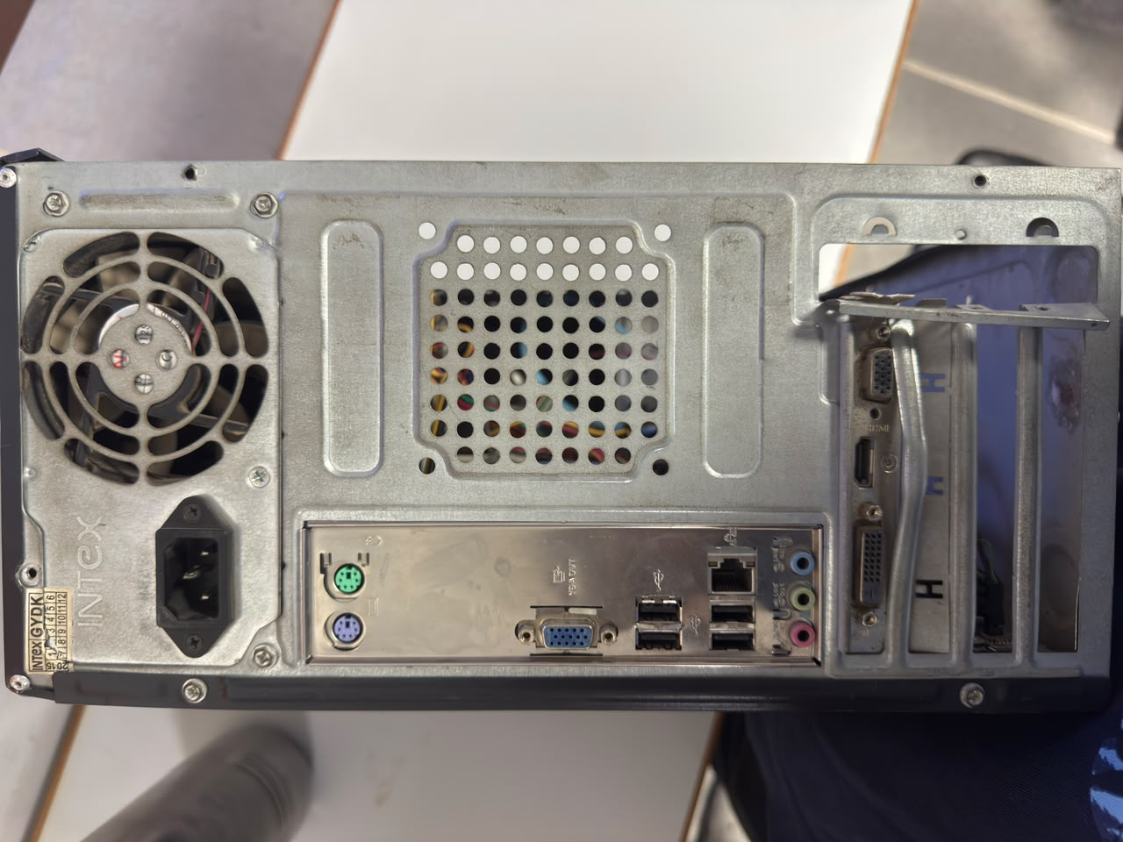
- Step 2: Remove the Side Panel
- Unscrew the side panel of the cabinet and slide it off to expose the internal hardware components.

- Step 3: Identify Internal Components
- Observe and identify the major components inside the PC, including the motherboard, CPU cooler, RAM, graphics card, storage drive, power supply, and case fan.
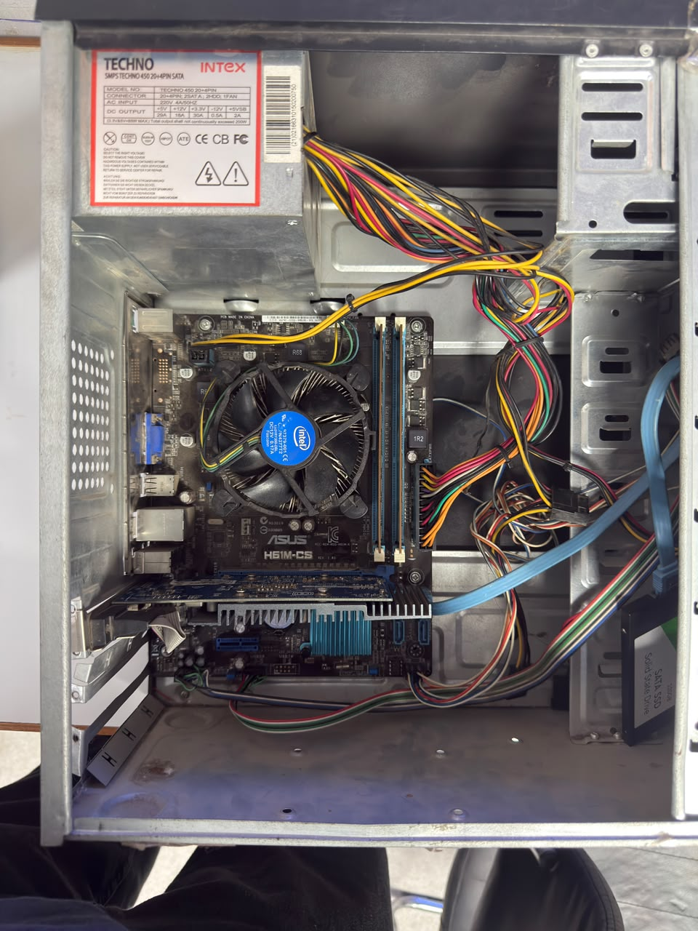
- Step 4: Disconnect Power Cables
- Carefully disconnect the 24-pin motherboard power connector, CPU power connector, GPU power cable (if present), and power cables connected to storage devices.
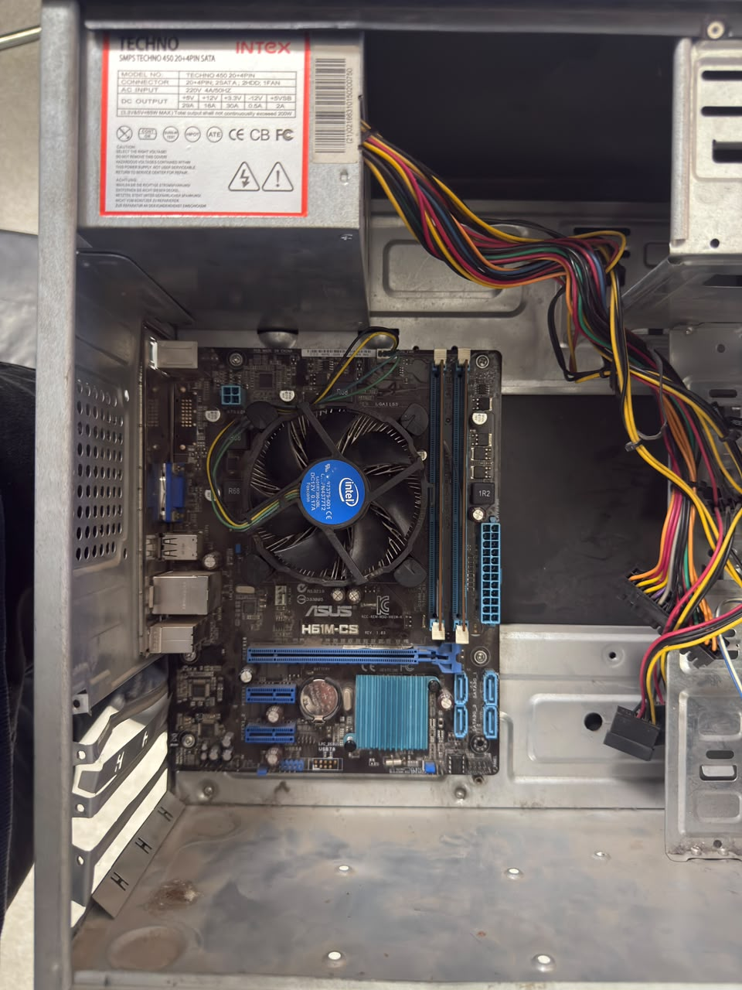
- Step 5: Remove the Graphics Card (GPU)
- Unscrew the graphics card from the rear expansion slot. Press the PCIe slot latch and gently pull the graphics card straight out.


- Step 6: Disconnect Data Cables
- Disconnect the SATA data cables and any remaining internal cables connected to storage devices or accessories.


- Step 7: Remove the RAM
- Push the locking clips at both ends of the RAM slot outward and carefully lift the RAM module from the motherboard.
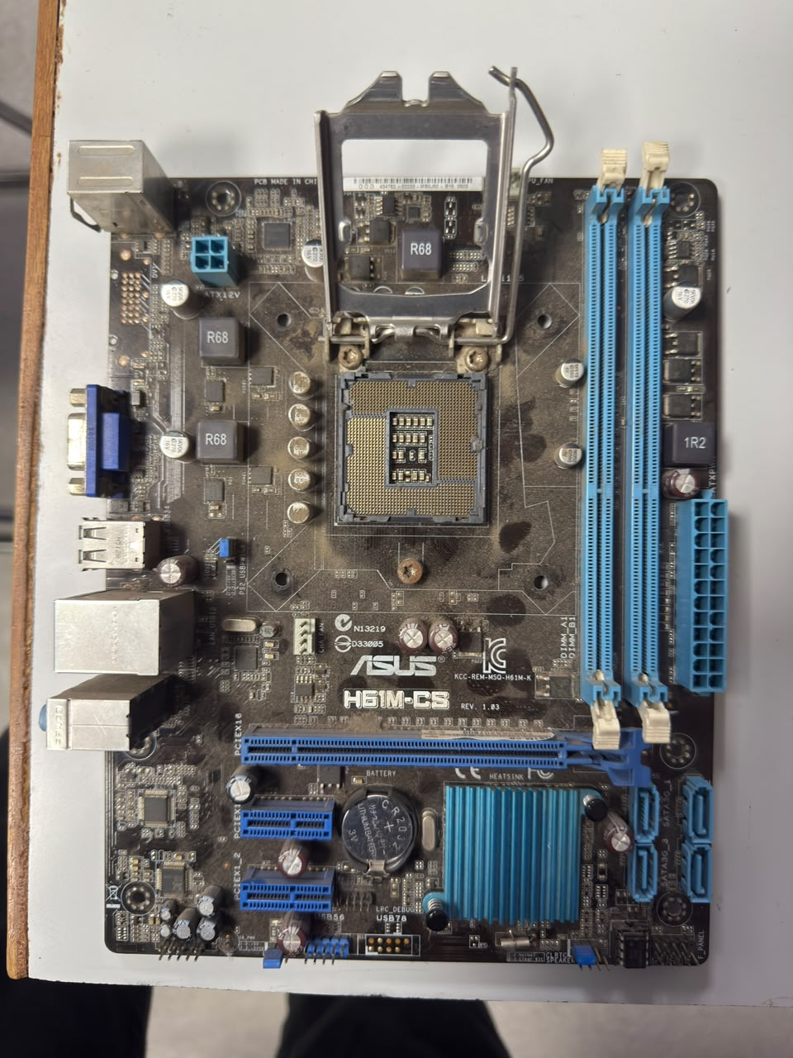
- Step 8: Remove the Storage Drive (HDD/SSD)
- Unscrew the hard drive or SSD from its mounting bracket or drive bay and slide it out carefully.
- Step 9: Remove the CPU Cooler
- Disconnect the CPU fan cable from the motherboard. Remove the mounting screws or clips holding the cooler and carefully lift it off the processor.
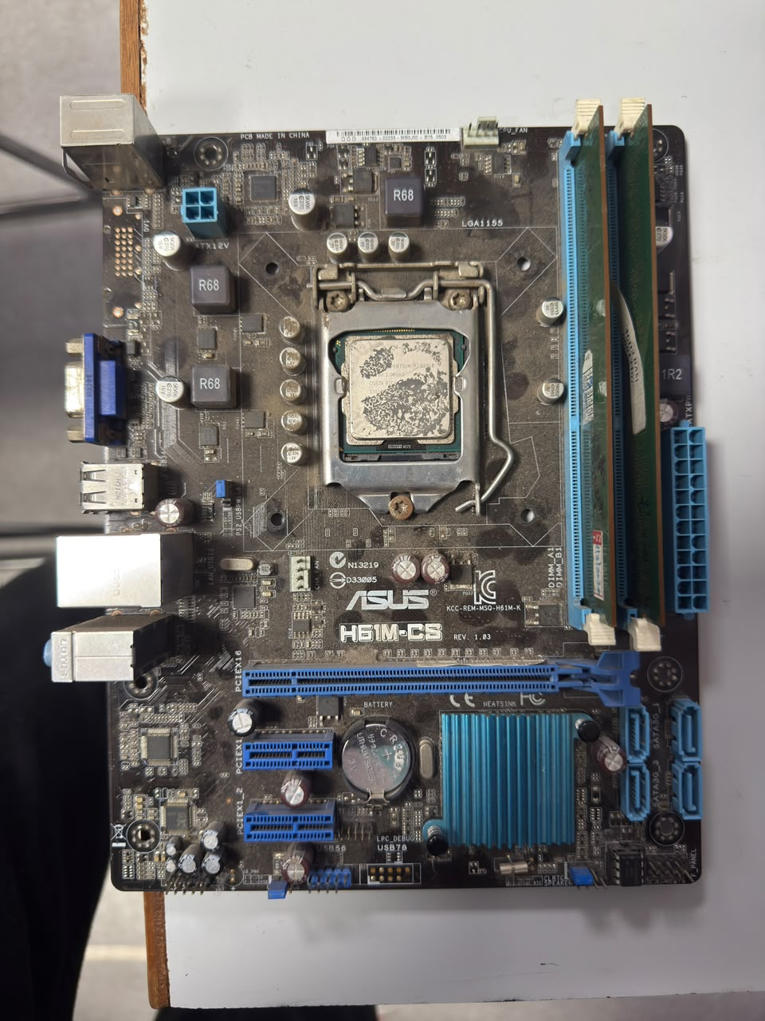
COLLER REMOVED

- Step 10: Remove the Motherboard
- Disconnect any remaining front panel or fan cables. Unscrew the motherboard from the cabinet standoffs and carefully lift it out.
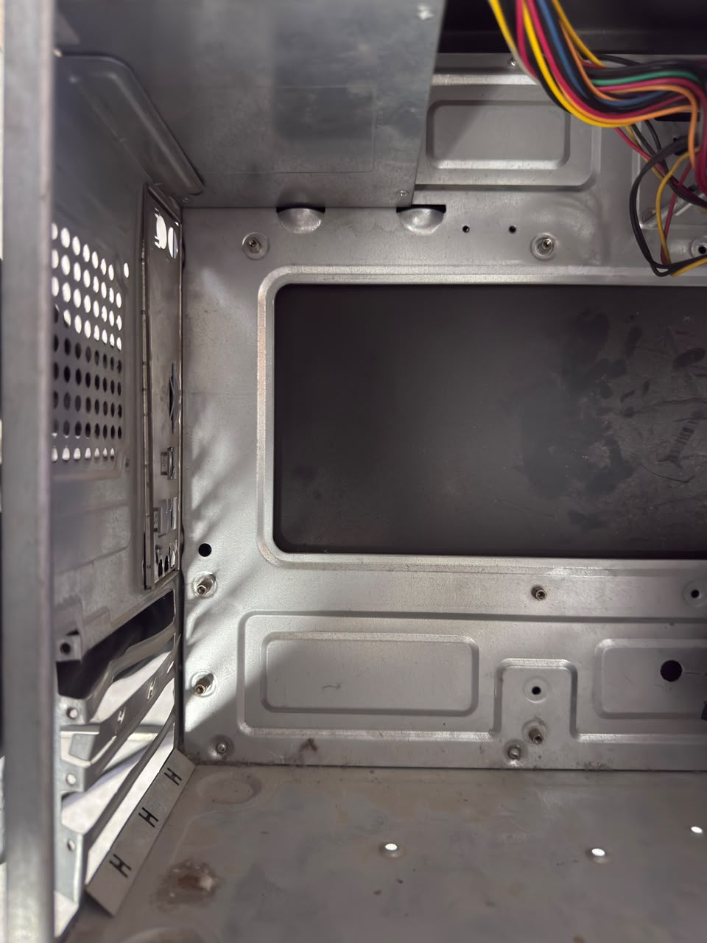
- Step 11: Remove the Power Supply Unit (PSU)
- Unscrew the PSU from the rear of the cabinet and slide it out after disconnecting all attached cables.
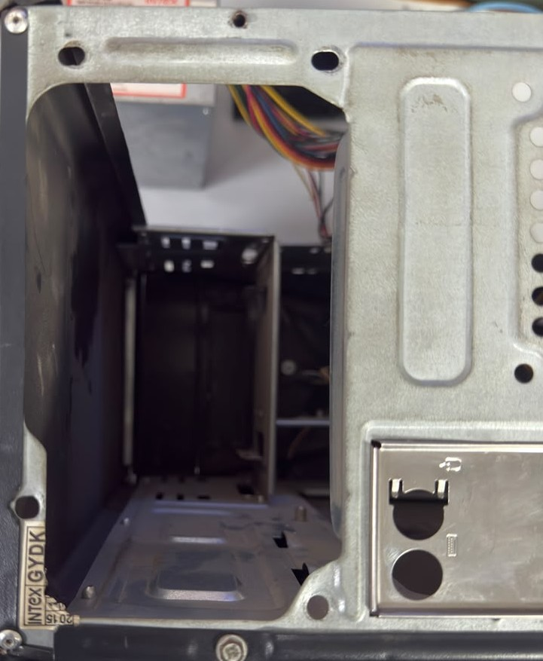
- Step 12: Final Inspection
- Verify that all components have been safely removed from the cabinet. Store all screws and components in a safe place for reassembly.
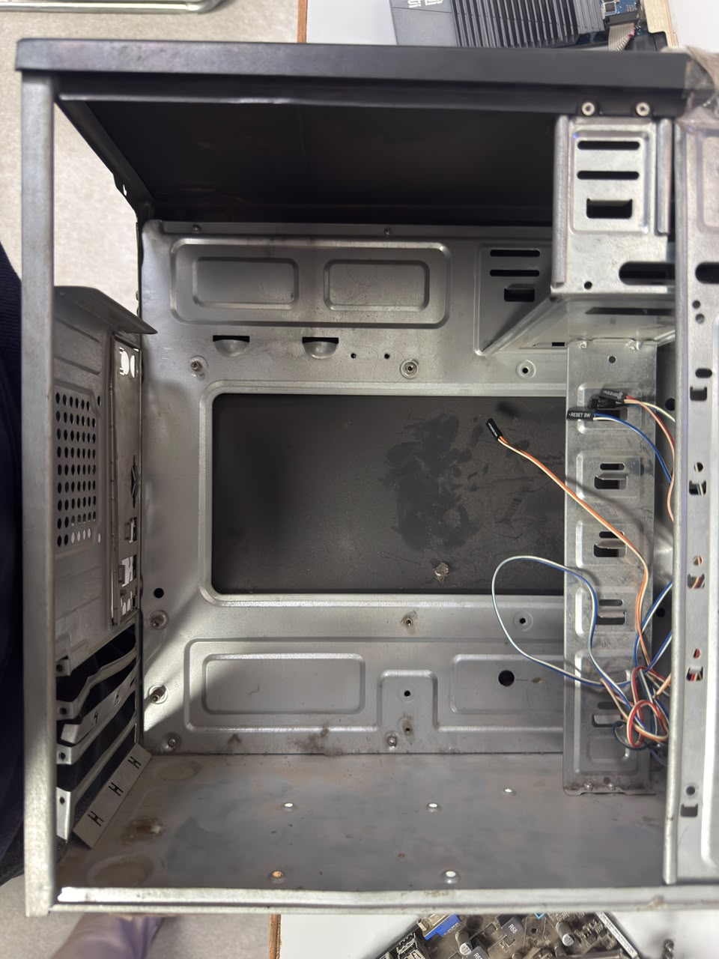
Q3. Reassemble the PC you disassembled, documenting each step with a brief explanation of what you connected or installed and why the order matters.
Ans.
- Reassembly Procedure
- Step 1: Install the Power Supply Unit (PSU)
- Place the PSU into its mounting position inside the cabinet and secure it with screws. Installing the PSU first provides power cables that will later be connected to other components.
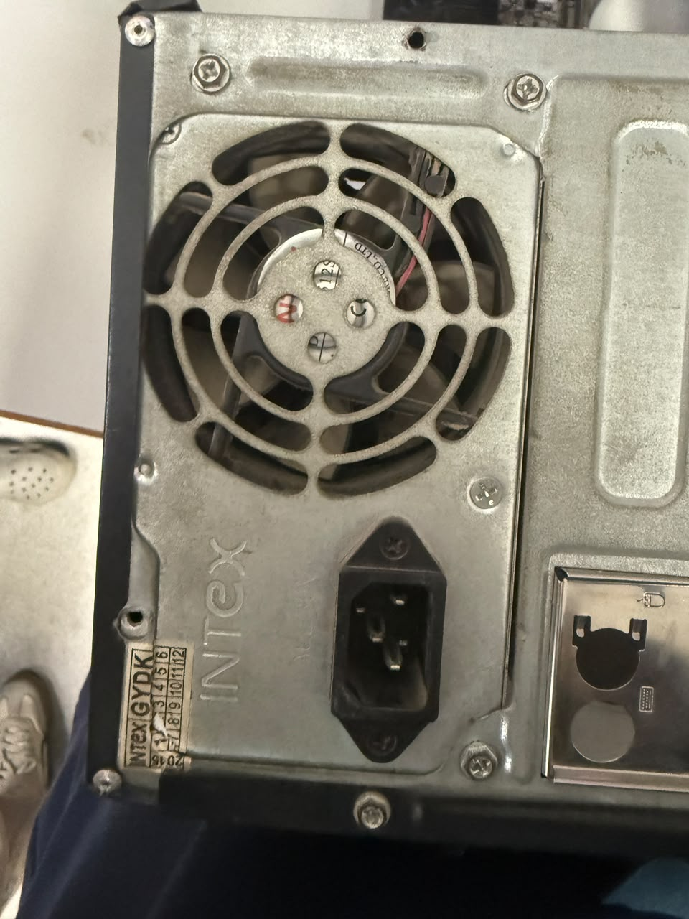
- Step 2: Install the Motherboard
- Carefully place the motherboard onto the standoffs inside the cabinet and secure it with screws. The motherboard must be installed early because it is the main board to which most components are connected.


- Step 3: Install the CPU Cooler
- Position the CPU cooler over the processor, apply thermal paste if required, tighten the mounting screws or clips, and connect the CPU fan cable to the motherboard. Proper cooling is essential before the system is powered on.
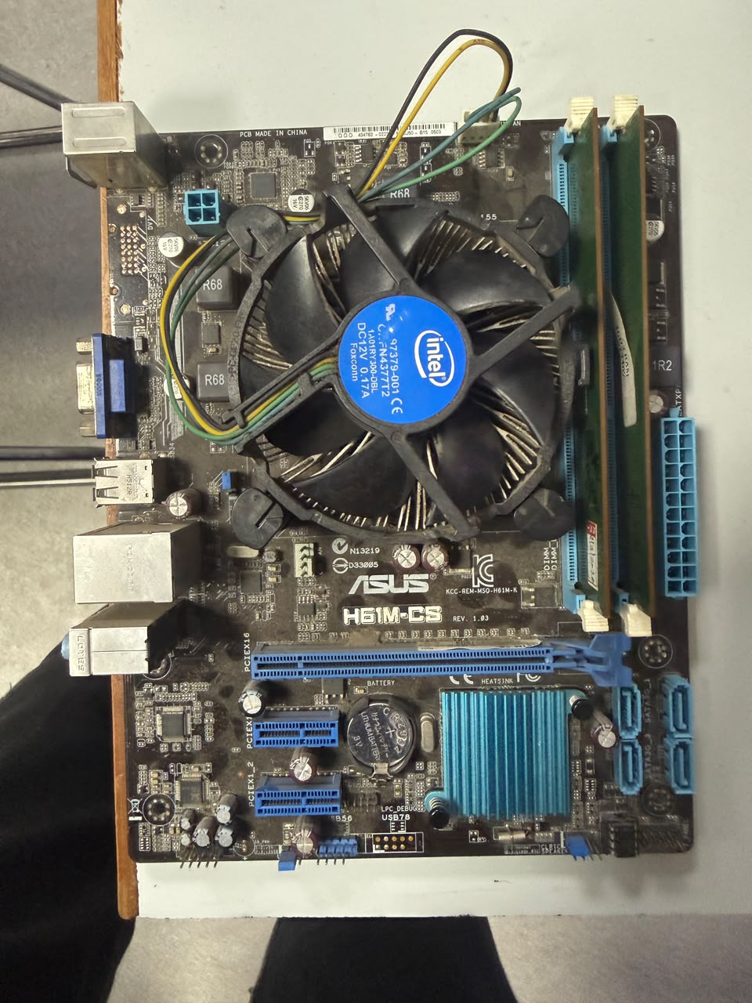
- Step 4: Install the RAM
- Align the RAM module with the memory slot and press it firmly until the locking clips click into place. Installing RAM now ensures the motherboard is ready to operate.

- Step 5: Install the Storage Drive (HDD/SSD)
- Mount the HDD or SSD into its drive bay and secure it with screws. This provides permanent storage for the operating system and user files.
- Step 6: Connect SATA Data and Power Cables
- Connect the SATA data cable from the motherboard to the storage drive and attach the SATA power cable from the PSU. Both connections are required for the drive to function properly

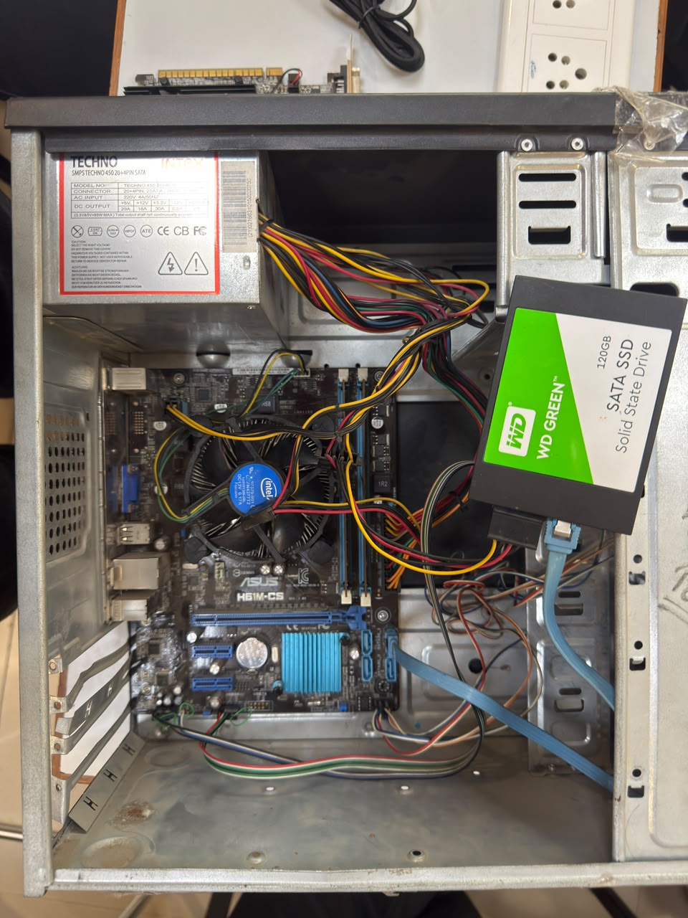

- Step 7: Install the Graphics Card (GPU)
- Insert the graphics card into the PCIe slot, press it firmly until it locks, and secure it with screws. Connect the PCIe power cable if the graphics card requires additional power.

- Step 8: Connect Motherboard Power Cables
- Connect the 24-pin motherboard power connector and the 4/8-pin CPU power connector from the PSU. These cables provide power to the motherboard and processor.

- Step 9: Connect Front Panel and Fan Cables
- Reconnect the power switch, reset switch, HDD LED, power LED, USB, audio, and case fan cables to the motherboard. These connections allow the front panel buttons, ports, and cooling fans to function correctly.

- Step 10: Check Cable Management
- Arrange all cables neatly using cable ties if available. Proper cable management improves airflow and makes future maintenance easier.
- Step 11: Close the Cabinet
- Reattach the side panel and tighten the screws securely. The cabinet protects the internal components from dust and accidental damage.
- Step 12: Power On and Test
- Reconnect the external cables and power cord, then switch on the computer. Verify that the system boots successfully and that all installed components are detected correctly.

Q4. Create a checklist of safety precautions and tools needed before starting the PC assembly/disassembly process, and explain why each is important.
Ans.
- Checklist of Safety Precautions and Tools for PC Assembly/Disassembly

Safety Precaution | Why It Is Important
Turn off the computer completely. | Prevents damage to components and reduces the risk of electrical shock.
Unplug the power cable. | Ensures that no electrical power is supplied to the PC while working.
Disconnect all external devices. | Prevents accidental damage to connected peripherals and makes handling easier.
Press the power button for 5–10 seconds after unplugging. | Discharges any remaining electricity stored in the system.
Wear an anti-static wrist strap or ground yourself. | Protects sensitive electronic components from electrostatic discharge (ESD).
Work on a clean, flat, and dry surface. | Prevents components from falling, getting dirty, or being damaged.
Handle components by the edges. | Avoids touching delicate circuits, chips, and gold contacts.
Keep screws in a small container. | Prevents screws from getting lost during assembly or disassembly.
Do not force any component into place. | Prevents bending pins, breaking connectors, or damaging hardware.
Follow the motherboard or PC manual if unsure. | Ensures components are removed and installed correctly.

- Tools Required
Tool | Why It Is Important
Phillips-head screwdriver | Used to remove and tighten most screws inside the PC.
Anti-static wrist strap | Prevents electrostatic discharge that can damage components.
Small container or magnetic tray | Keeps screws and small parts organized.
Soft microfiber cloth | Used to clean dust from components without scratching them.
Compressed air can | Safely removes dust from fans, heatsinks, and other components.
Thermal paste (if removing the CPU cooler) | Required to ensure proper heat transfer between the CPU and cooler during reassembly.

